SUMMARY REPORT FOR THE OFFICE OF THE ONTARIO REGIONAL CHIEF
Monday | Tuesday | Wednesday | Thursday | Friday
4 | 5 | 6 | 7 | 8
 | - EOC  - First Nations Sub-table | - COO Directors Meeting  - COO/IAO Prosperity Table Discussion  - AFN COVID-19 Task Force | - ISC/FNIHB COVID-19 update | - Chief Waylon Scott Re: COVID
11 | 12 | 13 | 14 | 15
- AFN Fundraising Committee | - EOC  - COO Justice Forum | - Leadership Council Meeting | - Leadership Council and First Nations Chiefs Meeting  - First Nations Sub-table  - ISC/FNIHB COVID-19 update | - Vaccine Distribution Task Force  - FPT Ministers and the National Indigenous Leaders and Reps
18 | 19 | 20 | 21 | 22
- OFNTSC Water Meeting  - AFN Bi-weekly Regional Staff  - First Nations Sub-table | - EOC  - WAHA Re: COVID  - Vaccine Distribution Task Force | - Leadership Council meeting with COO Secretariat Depts.  - Dr. Penny Sutcliffe  - AFN COVID-19 Task Force | - Vaccine Distribution Task Force  - First Nations Sub-table | - Marten Falls Pandemic Meeting  - Clear Directions
25 | 26 | 27 | 28 | 29
- Cindy Blackstock Re: CHRT Orders | - EOC  - Ontario Engagement of First Nations Chapter of MMIWG NAP  - AFN Regional Chiefs discussion on Women’s File | - Webinar: Addressing Anti-Indigenous Racism in Canada’s Health Care  - ISC Re: Water | - Webinar: Addressing Anti-Indigenous Racism in Canada’s Health Care  - Deputy SolGen Deborah Richardson  - COVID-19 Speaker Series  - ISC/FNIHB COVID-19 Update
Please find a summary of highlights for January. Numerous conference calls were held with all levels of government including ISC/FNIHB, AFN COVID-19 Task Force, EOC Operations, Vaccine Distribution Task Force, First Nation Vaccination Sub-table, COO/IAO Prosperity Table, Deputy Solicitor General Deborah Richardson.
JANUARY 2021 CALENDAR OF EVENTS/MEETINGS

Calendar of Events/Meetings

CONFIRMED CASES BY COMMUNITY
- The Southwest region has experienced the most cases of COVID-19.
- There are currently 87 active COVID-19 cases within First Nations communities.
- The current total resolve rate is 85%.
- There have been 556 cases in the second wave so far, compared to just 66 cases in the first wave.
- During the second wave, our cases have increased by 842%.

- A total of 12 communities currently have active cases this week:

    - Six Nations
    - Akwesasne
    - Aamjiwnaang
    - Wauzhushk Onigum
    - Kettle and Stony Point
    - Oneida Nation of the Thames
    - Walpole Island
    - Beausoleil
    - Ginoogaming
    - Constance Lake
    - Delaware Nation at Moraviantown
    - Wahta

Please note: We have reformatted our chart to show total cases by geographical region.

CONFIRMED CASES BY REGION & COMMUNITY: March 11 – January 27
Community | Confirmed Cases | Resolved | Deaths | Active Cases
North West Region
Wabaseemoong | 21 | 21 |  | 0
Kiashke Zaagiing | 8 | 8 |  | 0
Wauzhushk Onigum | 6 | 5 |  | 1
Sandy Lake | 5 | 4 | 1 | 0
Shoal Lake 40 | 5 | 5 |  | 0
Whitesand | 5 | 5 |  | 0
Eabametoong | 4 | 4 |  | 0
Long Lake No. 58 | 4 | 4 |  | 0
Niisaachewan | 3 | 3 |  | 0
Rainy River | 3 | 3 |  | 0
Fort William | 2 | 2 |  | 0
Keewaywin | 2 | 2 |  | 0
Animbiigoo Zaagi’igan | 1 | 1 |  | 0
Aroland | 1 | 1 |  | 0
Deer Lake | 1 | 1 |  | 0
Iskatewizaagegan No. 39 | 1 | 1 |  | 0
Kingfisher Lake | 1 | 1 |  | 0
Lac Seul | 1 | 1 |  | 0
Pikangikum | 1 | 1 |  | 0
Sachigo Lake | 1 | 1 |  | 0
Washagamis Bay | 1 | 1 |  | 0
Total for North West Region | 77 | 75 | 1 | 1
North East Region
Constance Lake | 17 | 8 |  | 9
Moose Factory | 11 | 11 |  | 0
Magnetawan | 9 | 9 |  | 0
Ginoogaming | 6 | 0 |  | 6
Attawapiskat | 5 | 5 |  | 0
Fort Albany | 2 | 2 |  | 0
Wiikwemkoong | 2 | 2 |  | 0
Atikameksheng | 1 | 1 |  | 0
Mishkeegogamang | 1 | 1 |  | 0
Ojibways of Garden River | 1 | 1 |  | 0
Total for North East Region | 55 | 40 | 0 | 15
South West Region
Six Nations | 146 | 131 | 1 | 14
Oneida Nation of the Thames | 92 | 75 |  | 17
Walpole Island | 32 | 26 | 1 | 5
Aamjiwnaang | 16 | 15 |  | 1
Delaware Nation at Moraviantown | 14 | 5 |  | 9
Chippewas of the Thames | 13 | 13 |  | 0
Kettle & Stoney Point | 10 | 7 |  | 3
Mississaugas of Credit | 5 | 5 |  | 0
Chippewas of Saugeen | 4 | 4 |  | 0
Chippewas of Nawash | 2 | 2 |  | 0
Total for South West Region | 334 | 283 | 2 | 49
South East Region
Akwesasne | 147 | 123 | 6 | 18
Mohawks of the Bay of Quinte | 1 | 1 |  | 0
Total for South East Region | 148 | 124 | 6 | 18
Central Region
Beausoleil | 3 | 2 |  | 1
Wahta | 3 | 0 |  | 3
Alderville | 2 | 2 |  | 0
Curve Lake First Nation | <10* | <10* |  | 0
Total for Central Region | 8 | 4 | 0 | 4
TOTALS | 622 | 526 | 9 | 87
LEGEND: <10 - Specific case numbers not released
* - Cases not included in Totals

ORC OFFICE PANDEMIC INITIATIVES

Newsletters
- A COVID-19 vaccine newsletter will be sent out January 29. The newsletter provides updates and information as well as answers to frequently asked questions.

Proposals
- A proposal for universal masks is being produced. The purpose of this proposal is to secure funding that will supply as many First Nations children and adults on and off reserve with 3-layer cotton masks to help protect community members from COVID-19.

Research Papers
- A first draft has been completed on COVID-19 outbreaks in First Nations communities across Canada. The paper will include details on how COVID-19 was spread, how communities contained the spread and lessons learned.
- The research paper on food sovereignty has been completed and pending review. The paper focuses on food trade networks, sustainability, community programs and ways to support market economies.
- A research paper is being drafted that examines the federal debt that has resulted from the COVID-19 pandemic. This paper will highlight how COVID-19 has affected the economy and the potential short, medium and long-term implications for First Nations.

COVID-19 Speaker Series
- The ORC Office will hold the next COVID-19 Speakers Series where we provide an opportunity for you to hear directly from experts on topics related to the pandemic. If you missed any of the sessions then visit the ORC’s social media for #ThrowbackThursday posts.
  - Next session: Dr. Restoule and Dr. Hopkins will present on mental health during COVID-19 on February 11, 2021 at 2:00pm.

PROVINCIAL MEASURES RESPONDING TO COVID-19

- Ontario extends the Reopening Ontario Act for another 30 days.
- Ontario expands to phase two of vaccine distribution roll out plan
- Due to Pfizer-BioNTech shipment delays, Ontario accelerating the vaccination of residents in First Nations elder care homes by a new target date of February 5, 2021.
- $29.3 million to support small air carriers serving remote First Nations communities in Northern Ontario to ensure access to essential goods and services during COVID-19.
- Ontario extends online learning in Southern Ontario until January 25. Also extends provincewide shutdown in Northern Ontario.
- Second provincial emergency declared issuing stay-at-home order and enhanced enforcement measures to reduce mobility.
- $10.9 million to bring faster broadband to several towns and First Nation communities across Northern Ontario
- $9.4 million to improve and deliver reliable internet across Brant County and within Six Nations of the Grand River.
- $5.3 million to help small and medium sized forest sector businesses for COVID-19 safety measures.
- Ontario Temporarily Pauses Residential Evictions
- Ontario working to enhance workplace opportunities for Indigenous, Black and racialized employees via virtual roundtable discussions.
- $200-million investment through the 2021 Ontario Community Infrastructure Fund (OCIF) to help 424 small, rural and northern communities build and repair roads, bridges, water and wastewater infrastructure.
- Applications now open for up to $20,000 Small Business Support Grant for eligible businesses impacted by provincial shutdown

FEDERAL MEASURES RESPONDING TO COVID-19

- Allocated an additional $380 million for the Indigenous Community Support Fund.
- $1 million to support the COVID-19 Evidence Network to bring together experts to discuss Canada's COVID-19 pandemic response.

NEW CASES IN ONTARIO
- More than 1600 cases were reported every day this week.
- Cases ranged between 1600 and 2600 daily.
- The weekly 7-day average reported was 2128 cases, a decrease of 23% from last week.
- A total of 14,899 cases were reported in Ontario this week.
  - Just over 4000 less cases than last week.

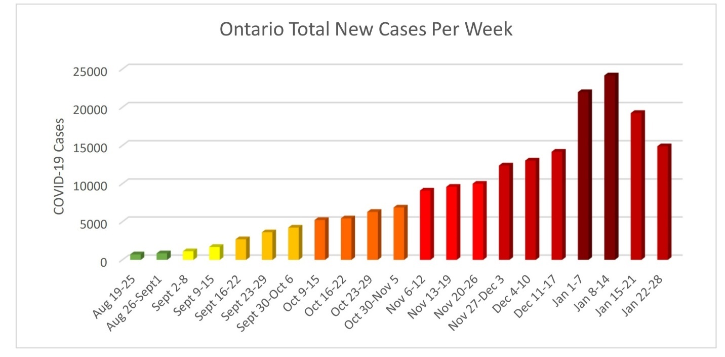

STATUS OF ONTARIO BY PUBLIC HEALTH UNIT

Active Cases Across Ontario:
- Ontario had an active week with over 17,000 cases being reported between January 18th and January 24th.
  - Total number reported: 17,216
- The highest number of cases reported this week was 3422 cases on January 17th.
- 25 out of 34 Public Health Units are at 70% or more capacity of ICU beds occupied.
  - 4 of these PHUs are at or over 100% capacity:
    - Eastern – 109%
    - York – 100%
    - Huron Perth – 117%
    - Hastings and Prince Edward – 111%

HOTSPOTS

- Region of Waterloo
- Simcoe Muskoka
- Ottawa
- Middlesex-London
- Niagara Region
- Durham
- Halton Region
- Hamilton
- Windsor-Essex County
- York
- Peel
- Toronto

WEEKLY SUMMARY OF NEW & ACTIVE CASES ACROSS ONTARIO BY PHU
January 18 – January 24, 2021

New Ontario Framework Categories (as of Jan 25) | Public Health Unit (PHU) | New cases  Jan 18-Jan 24 | Active cases  as of  Jan 24 | Resolved cases  as of  Jan 24 | Total ICU Beds Occupied as of Jan 25
Lockdown | North Bay Parry Sound | 4 | 2 | 2 | 56%
Lockdown | Renfrew | 5 | 3 | 2 | 33%
Lockdown | Timiskaming | 3 | 3 |  | N/A
Lockdown | Algoma | 10 | 13 |  | 69%
Lockdown | Northwestern | 16 | 18 |  | N/A
Lockdown | Kingston, Frontenac and Lennox & Addington | 21 | 19 | 2 | 91%
Lockdown | Leeds, Grenville and Lanark | 14 | 19 |  | 40%
Lockdown | Hastings and Prince Edward | 14 | 21 |  | 111%
Lockdown | Grey Bruce | 16 | 31 |  | 83%
Lockdown | Peterborough | 40 | 48 |  | 75%
Lockdown | Porcupine | 47 | 51 |  | 83%
Lockdown | Chatham-Kent | 96 | 74 | 22 | 80%
Lockdown | Sudbury & District | 53 | 86 |  | 86%
Lockdown | Haldimand-Norfolk | 76 | 102 |  | N/A
Lockdown | Haliburton-Kawartha, Pine Ridge | 86 | 106 |  | 33%
Lockdown | Brant County | 62 | 113 |  | 87%
Lockdown | Huron Perth | 129 | 145 |  | 117%
Lockdown | Thunder Bay District | 140 | 163 |  | 77%
Lockdown | Lambton | 170 | 171 |  | 86%
Lockdown | Southwestern | 154 | 188 |  | 95%
Lockdown | Eastern | 179 | 308 |  | 109%
Lockdown | Wellington-Dufferin-Guelph | 416 | 537 |  | 80%
Lockdown | Durham | 547 | 644 |  | 84%
Lockdown | Simcoe Muskoka | 463 | 679 |  | 69%
Lockdown | Hamilton | 611 | 725 |  | 85%
Lockdown | Halton Region | 510 | 743 |  | 87%
Lockdown | Region of Waterloo | 675 | 760 |  | 82%
Lockdown | Middlesex-London | 446 | 777 |  | 71%
Lockdown | Windsor-Essex County | 740 | 1002 |  | 87%
Lockdown | Niagara Region | 732 | 1060 |  | 93%
Lockdown | Ottawa | 656 | 1151 |  | 82%
Lockdown | York | 1520 | 1658 |  | 100%
Lockdown | Peel | 3106 | 4936 |  | 99%
Lockdown | Toronto | 5459 | 7797 |  | 96%

LEADERSHIP COUNCIL & CHIEFS MEETING
We are switching our Leadership Council meetings to Mondays.
Further, we are switching the Leadership Council and Chiefs meetings to Tuesdays.

We are doing this to accommodate the many year-end meetings that are conflicting with our usual meeting days.

Our next bi-weekly meeting for the Leadership Council will be held on Monday, February 22nd, 2021.

Our next bi-weekly meeting for the Leadership Council & Chiefs will be held on Tuesday, February 23rd, 2021.

